- Purpose

This procedure describes how to prepare and test liquid load and salt samples for analysis on the SPEC 20 to obtain a “color” value.

- Scope

This procedure should be performed on every daily crystal sample and on liquid load products.

- Responsibility

QA Lab personnel and material handlers are responsible for performing this procedure.

- Safety Considerations

Appropriate PPE must be worn for the area tester is working in.

Safety is a condition of employment. Employees are not authorized to work in an unsafe manner and are prohibited from harming the environment of the facility or community.

- Materials/Equipment

- Weighing Balance – B 440 Sartorius or equivalent
- Thermo Scientific Genesys 20 Vis Wavelength Detector
- Glass 500mL Beaker
- Magnetic Stir Plate
- Magnetic Stir Bar
- De-ionized Water
- Plastic Disposable Cuvettes
- Disposable Pipettes
- 100mL Graduated Cylinder

- Procedure

Note: The Detector must be turned on using the switch on the rear of the machine 30min before use. Plastic Cuvettes have two sides, the smooth side must be facing towards you (Image 1). The sample door must be closed when zeroing the machine or analyzing samples.

Liquid Product

- Change the wavelength on the Genesys 20 using the 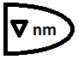 button until the LED display reads 325nm.
- Using a disposable pipette fill a new, clean cuvette with de-ionized water and insert it into the sample holder. Note: DO NOT touch the smooth side of the cuvette with bare hands. Fingerprints may skew the results.
- Zero the instrument using the 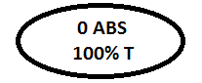 button.
- Remove the cuvette and dispose of the Di water. Refill the same cuvette with the liquid sample. Note: DO NOT re-zero the instrument.
- Take the number displayed off of the LED screen and refer to the Color Conversion Chart below for the color correspondence and record on Final Product Liquid – Daily Quality Control Report (L12-FM-100-006).

Crystalline Product

- Tare the 500 ml beaker to zero on the weighing balance
- Add 75 grams of Crystal Product to the beaker
- Add 90 ml. of De-ionized water to the beaker
- Place the stirring bar in the beaker and place the beaker on the magnetic stirring plate.
- Allow stirring to continue until all of the crystals have disappeared.
- Proceed as directed above in numbers 1-4.
- Take the number displayed off of the LED screen and refer to the Color Conversion Chart below for the color correspondence and record on Final Product Crystal – Daily Quality Control report (L12-FM-100-002)

7.0 Reference Documents

Final Product Liquid – Daily Quality Control Report (L12-FM-100-006)
Final Product Crystal – Daily Quality Control report (L12-FM-100-002)

8.0 Amendment Record

New Document

Color Values Chart
Value | Color | Value | Color
0.000 | 0 | 0.185 | 26
0.012 | 1 | 0.192 | 27
0.019 | 2 | 0.199 | 28
0.026 | 3 | 0.206 | 29
0.033 | 4 | 0.212 | 30
0.040 | 5 | 0.219 | 31
0.047 | 6 | 0.226 | 32
0.054 | 7 | 0.233 | 33
0.061 | 8 | 0.240 | 34
0.068 | 9 | 0.247 | 35
0.074 | 10 | 0.254 | 36
0.081 | 11 | 0.261 | 37
0.088 | 12 | 0.268 | 38
0.095 | 13 | 0.274 | 39
0.102 | 14 | 0.281 | 40
0.109 | 15 | 0.288 | 41
0.116 | 16 | 0.295 | 42
0.123 | 17 | 0.302 | 43
0.130 | 18 | 0.309 | 44
0.137 | 19 | 0.316 | 45
0.143 | 20 | 0.323 | 46
0.150 | 21 | 0.330 | 47
0.157 | 22 | 0.337 | 48
0.164 | 23 | 0.343 | 49
0.171 | 24 | 0.350 | 50
0.178 | 25 | 0.357 | 51

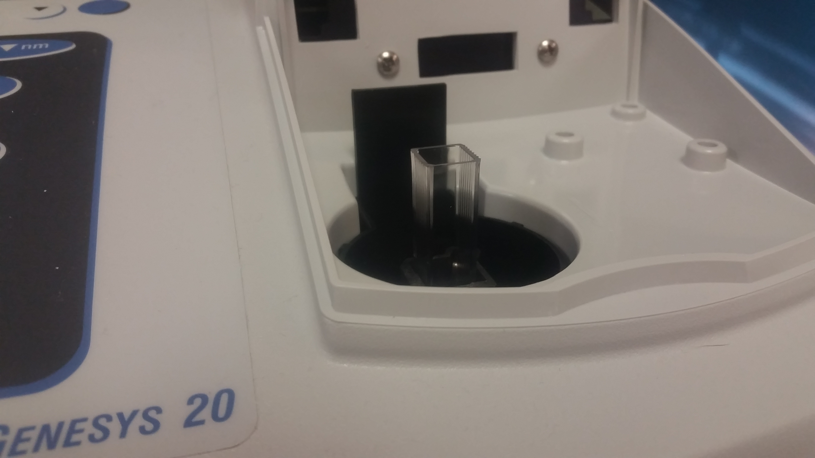

Image 1

Color Conversion Chart
* Values for this chart were created using colored standards made
by visual comparison with Orbeco-Hellige Aqua Tester.

